Influence of Culture on Emotion

Culture can have a profound impact on the way in which people display, perceive, and experience emotions.

LEARNING OBJECTIVES

Give examples of universal vs. culturally dependent aspects of emotional expression

Key Points
- The culture in which we live provides structure, guidelines, expectations, and rules to help us understand, interpret, and express various emotions.
- A “cultural display rule” is a culturally specific standard that governs the types and frequencies of emotional displays considered acceptable by a given culture.
- Cultural scripts dictate how positive and negative emotions should be experienced and displayed; they may also guide how people choose to regulate their emotions, ultimately influencing an individual’s emotional experience.
- Cultural contexts also act as cues when people are trying to interpret facial expressions. This means that different cultures may interpret the same social context in very different ways.
- Despite different emotional display rules, our ability to recognize and produce basic facial expressions of emotion appears to be universal. In fact, research has discovered seven basic types of emotions expressed in human faces: sadness, happiness, disgust, surprise, anger, contempt, and fear.
- Complex emotions such as jealousy, love, and pride are different from basic emotions and are more likely to be dependent on cultural influences than are more basic emotions.

Key Terms

- emotion: The complex psychophysiological experience of an individual’s state of mind as it interacts with biochemical (internal) and environmental (external) influences.
- culture: A shared set of beliefs, attitudes, norms, values, and behavior organized around a central theme and found among speakers of one language, in one time period, and in one geographic region.

Culture—i.e., the beliefs, values, behavior, and material objects that constitute a people’s way of life—can have a profound impact on how people display, perceive, and experience emotions. The culture in which we live provides structure, guidelines, expectations, and rules to help us understand and interpret various emotions.

Expressing Emotions

A cultural display rule dictates the types and frequencies of emotional displays considered acceptable within a certain culture (Malatesta & Haviland, 1982). These rules may also guide how people choose to regulate their emotions, ultimately influencing an individual’s emotional experience and leading to general cultural differences in the experience and display of emotion.
For example, in many Asian cultures, social harmony is prioritized over individual gain, whereas Westerners in much of Europe and the United States prioritize individual self-promotion. Research has shown that individuals from the United States are more likely to express negative emotions such as fear, anger, and disgust both alone and in the presence of others, while Japanese individuals are more likely to do so only while alone (Matsumoto, 1990). Furthermore, individuals from cultures that tend to emphasize social cohesion are more likely suppress their own emotional reaction in order to first evaluate what response is most appropriate given the situation (Matsumoto, Yoo, & Nakagawa, 2008).

Cultures also differ in the social consequences that they assign to different emotions: in the United States, men are often directly or indirectly ostracized for crying; in the Utku Eskimo population, the expression of anger can result in social ostracism.
Within a particular culture, different rules may also be internalized as a function of an individual’s gender, class, family background, or other factor. For instance, there is some evidence that men and women may differ in the regulation of their emotions, perhaps due to culturally based gender norms and expectations (McRae, Ochsner, Mauss, Gabrieli, & Gross, 2008).

Interpreting Emotions

In everyday life, information from the environment influences our understanding of what facial expressions mean. In much the same way, cultural context also acts as a cue when people are trying to interpret facial expressions. People can attend to only a small number of the available cues in their complex and continuously changing environments, and increasing evidence suggests that people from different cultural backgrounds allocate their attention very differently. This means that people from different cultures may interpret the same social context in very different ways.

Are Emotions Universal?

Although conventions regarding the display of emotion differ from culture to culture, our ability to recognize and produce associated facial expressions appears to be universal. Research comparing facial expressions across different cultures has supported the theory that there are seven universal emotions, each associated with a distinct facial expression. That these emotions are “universal” means that they operate independently of culture and language. These seven emotions are happiness, surprise, sadness, fright, disgust, contempt, and anger (Ekman & Keltner, 1997). Even congenitally blind individuals (people who are born blind) produce the same facial expressions associated with these emotions, despite never having had the opportunity to observe them in other people. This further supports the theory that the patterns in facial muscle activity are universal for the facial expressions of these particular emotions.

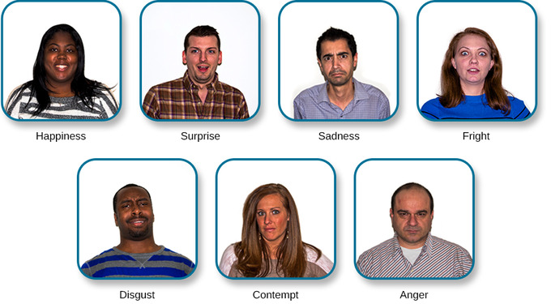

Universal facial expressions: Research suggests the existence of seven universal emotions, each of which is associated with a distinct facial expressions: happiness, surprise, sadness, fright, disgust, contempt, and anger.

It is worth noting that more complex emotions such as jealousy, love, and pride are different from these more basic emotions, as they involve awareness of the relationships between the self and other people. Complex emotions are therefore more likely to be dependent on cultural differences than are the seven more basic emotions.

